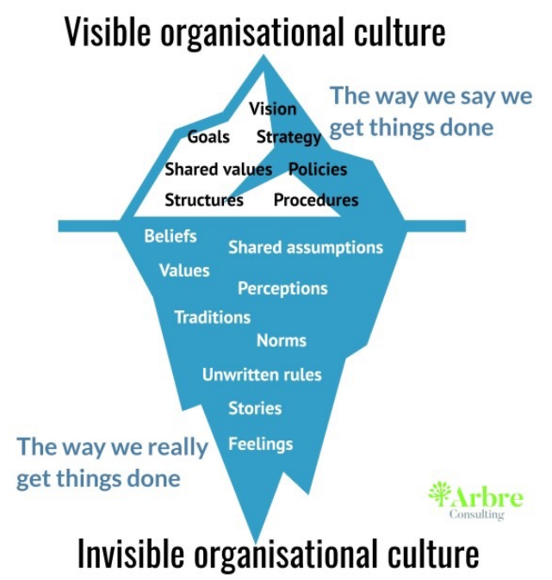**Culture and Project Management**

1. Definition of Organizational Culture
2. Project Manager’s Checklist
3. Team Challenges
4. Dealing with conflict

**Organizational Culture**

1. Shared beliefs, attitudes, values
2. Behaviours that arise from the beliefs, attitudes and values
3. May be obvious or subtle

**Project Manager’s Checklist**

1. Decision-making—who makes the decision and what processes are followed
2. Communication
   1. Formality
   2. Medium
   3. Complexity
3. Vocabulary and format— “Image”

**Team Challenges**

1. Individual identity
2. Verbal and emotional expressiveness
3. Relationship expectations
4. Style of communication
5. Language
6. Personal priorities, values and beliefs
7. Time orientation

**Dealing with Conflict**

1. Conflict is not a bad thing
2. Problem-solving is a key activity for successful teams
3. Understanding your own preferred approach and those of your team helps in productive conflict resolution

**Five basic approaches to conflict resolution**

1. Avoidance
2. Accommodation
3. Competition
4. Compromise
5. Collaboration

**Culture and Project Management**

1. Organizational Culture means shared beliefs, attitudes and values, along with related behaviours
2. Project Managers need to be aware of cultural issues
3. Team Members can also face challenges in cross-cultural relationships
4. Effectively dealing with conflict is a success factor for projects—every project team must resolve differences and make decisions